- The drop in UK CPI inflation in October primarily reflected a smaller rise in Ofgem's energy price cap than was seen last year. As a result, our inflation forecast is largely unchanged. We expect CPI inflation to average 2.8% in 2026 and 2.5% in 2027.
- We think inflation is likely to remain at similar levels over the final months of this year. But we expect to see a gradual cooling in price pressures next year as the energy category starts to weigh on the headline rate, food price inflation eases, and services inflation falls steadily due to weaker pay growth and base effects from this year's increase in national insurance contributions.
CPI inflation slowed to 3.6% in October from 3.8% in September. A smaller contribution from the energy category was the main reason for October's softer outturn, with the month's 2% rise in Ofgem's energy price cap much smaller than the increase seen last year. Services inflation also softened, though this was largely due to movements in volatile categories. These downward forces were more than enough to offset higher food and fuel prices. Elsewhere, RPI and RPIX inflation fell by 0.2ppts to sit at 4.3% and 4.2% in October.
Looking ahead, inflation is likely to remain at similar levels over the final months of this year, but several factors should pull the headline rate down through next year. Base effects should mean that the energy category starts to drag on inflation in H1 2026. We think food price inflation has probably passed its peak, with the impact of weaker food commodity prices and stronger sterling set to weigh on the category next year. Services inflation is expected to ease steadily due to cooling pay growth and strong base effects caused by this year's increase in national insurance contributions.
Our forecast is largely unchanged compared with last month, with CPI inflation forecast to average 2.8% in 2026 and 2.5% in 2027. The upcoming Budget on November 26 means there is an elevated degree of uncertainty surrounding the outlook. Pre-Budget media speculation has included measures that could have a direct impact on inflation, such as changing the VAT rate charged on household energy bills. We will reflect any Budget-related changes in next month's update.
Chart 1: Inflation is forecast to average 2.8% in 2026 and 2.5% in 2027
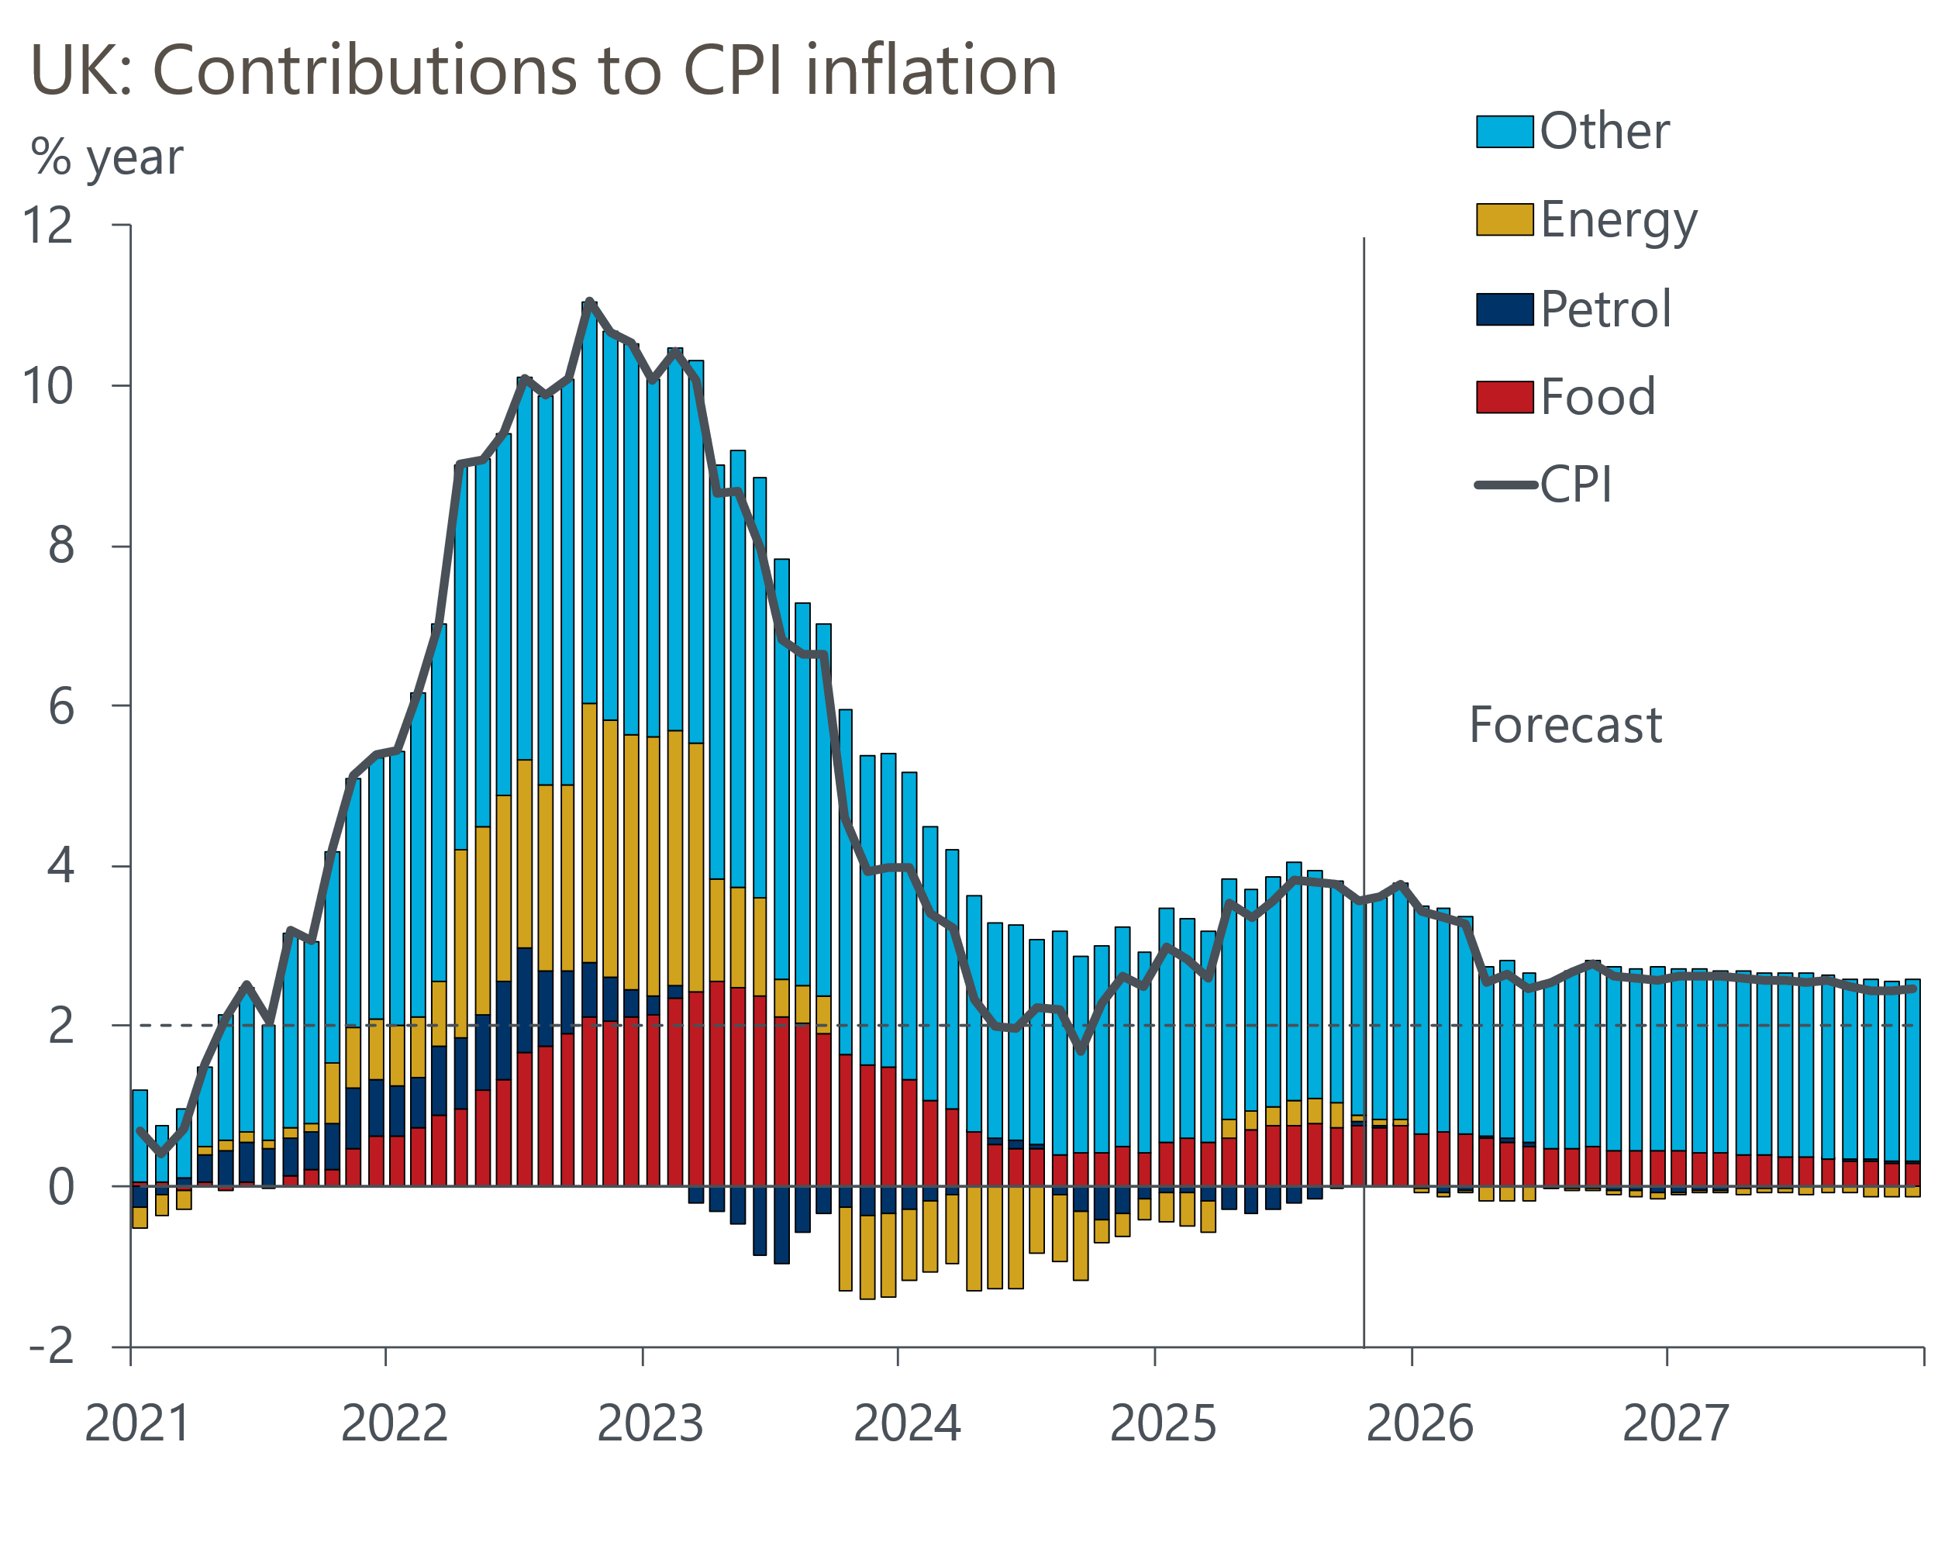
Source: Oxford Economics, Haver Analytics

